**Hybrid activation:-**

First we should create an instance

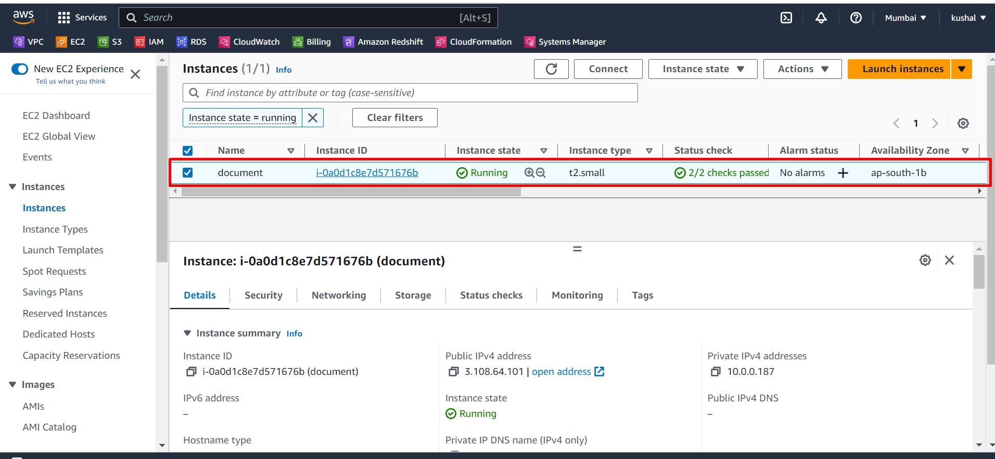

After that we search system manager in aws console and click on that.

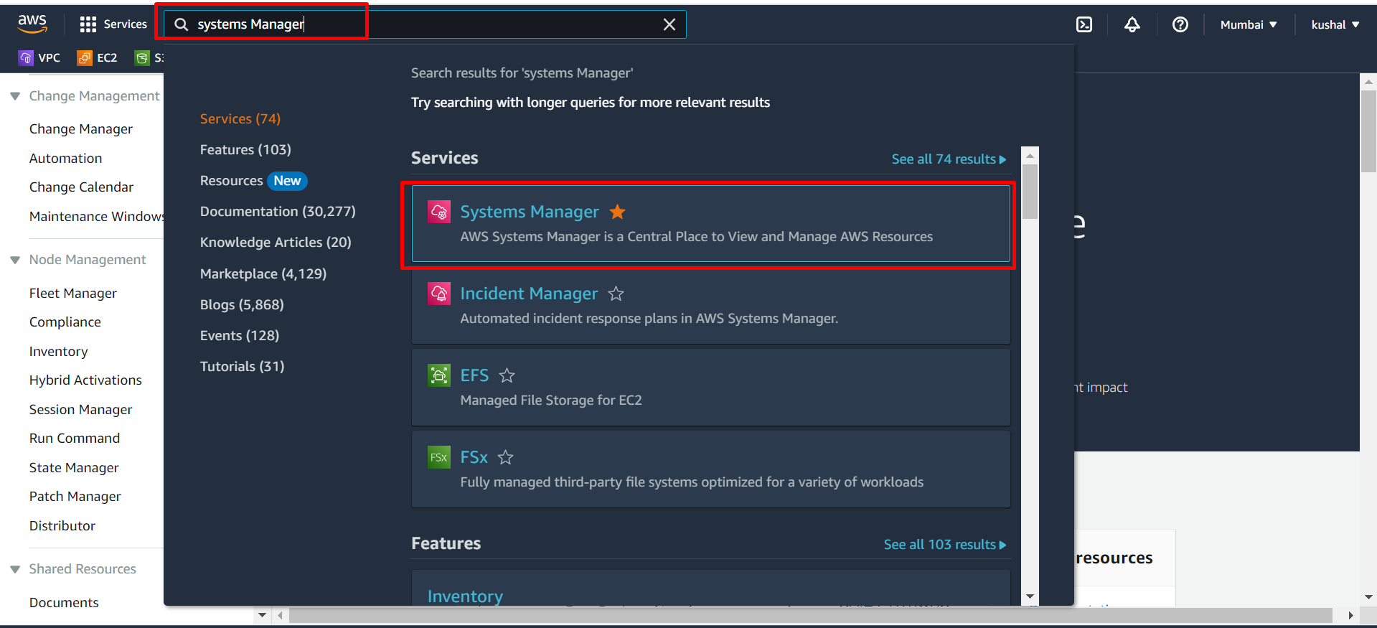

Next go to hybrid activations

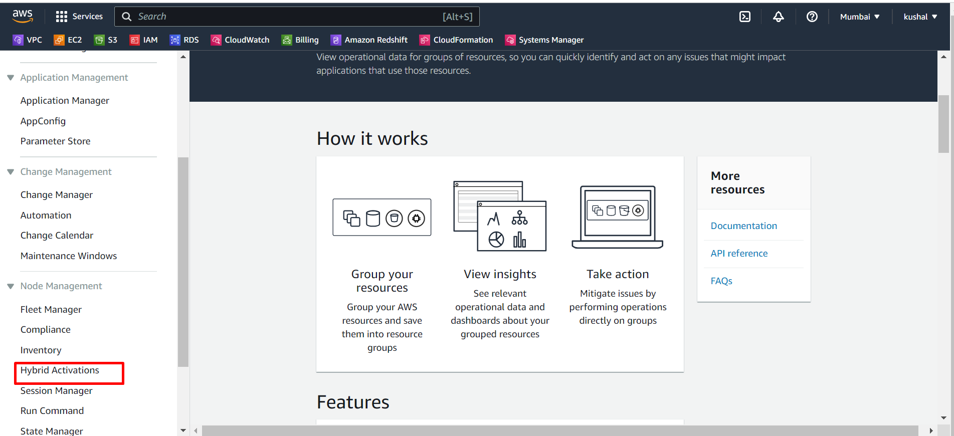

Next click on create activation.

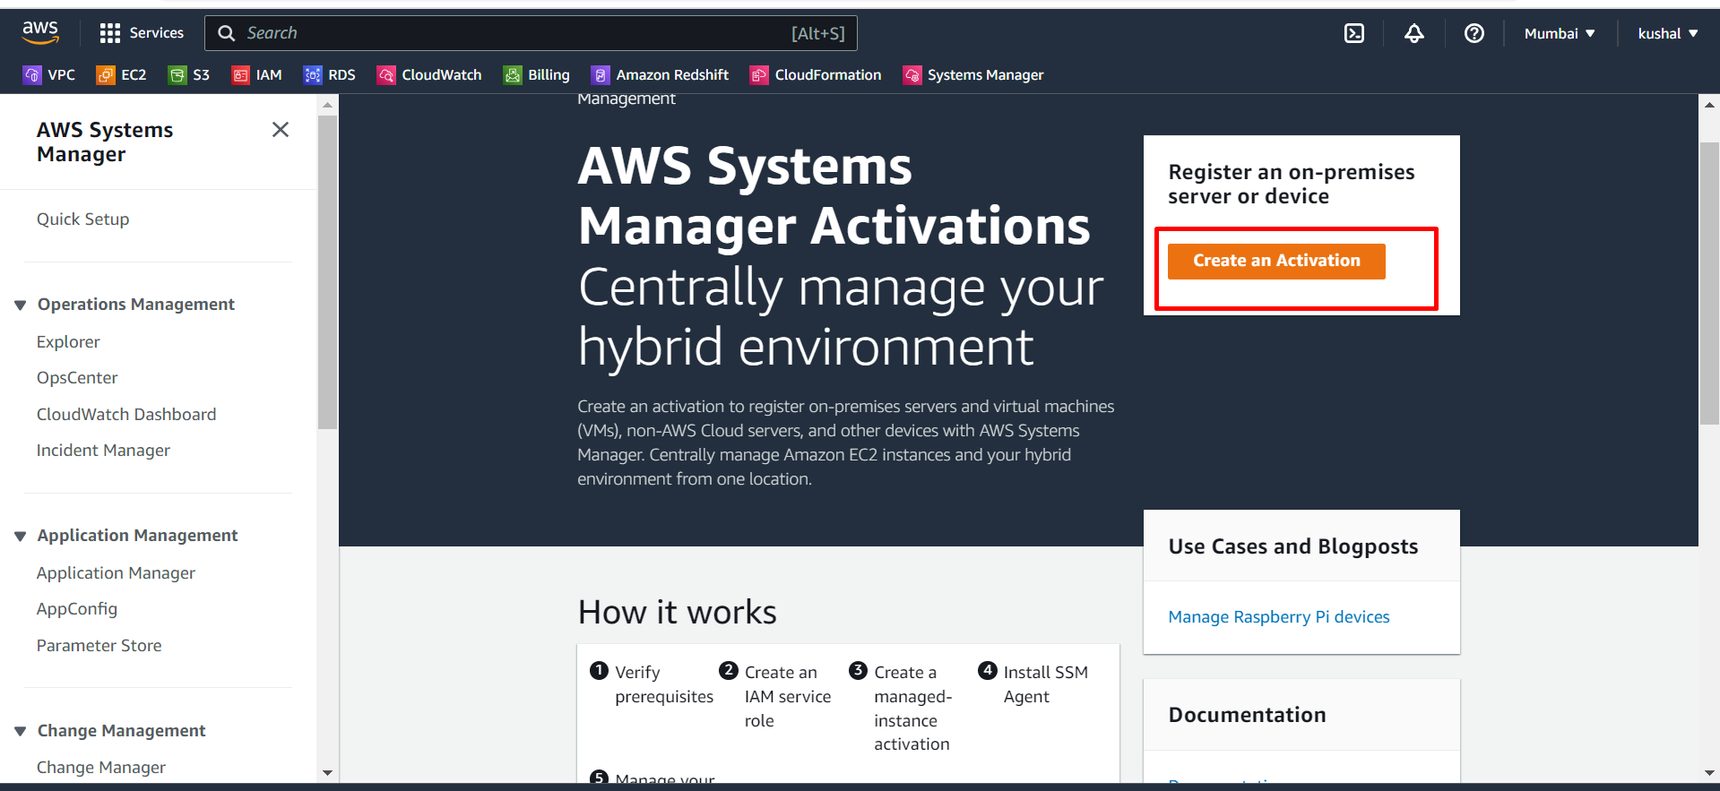

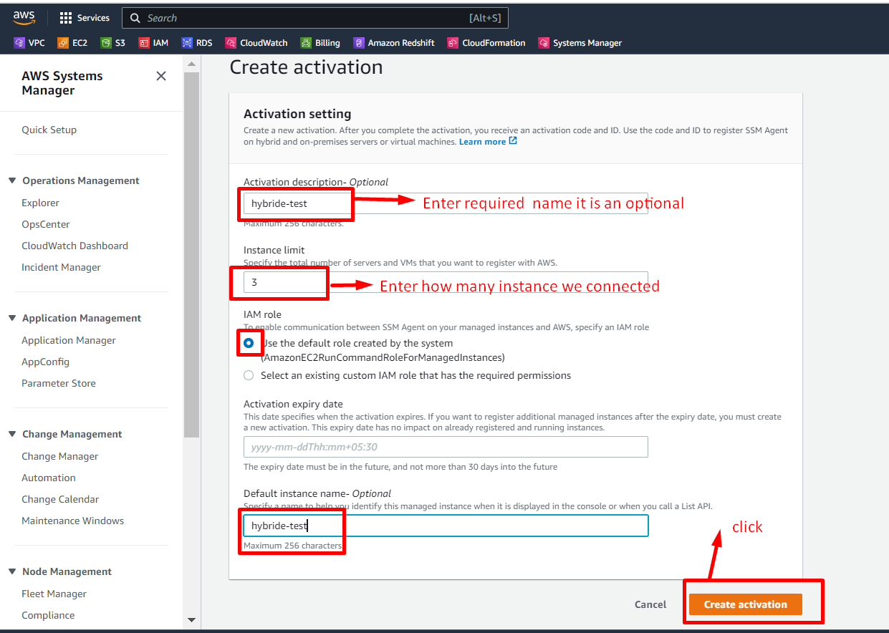

After that we had a some activation code and id are displays this are the most important so we need to copy this code and id and paste a notepad++.

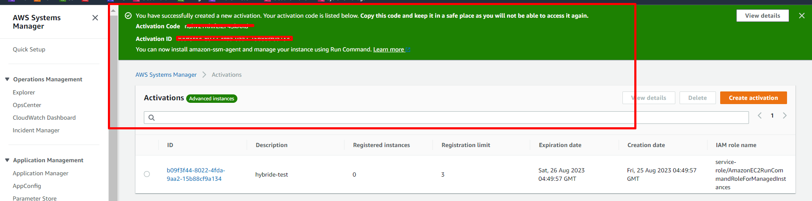

We stored activation code and id in notepad++.

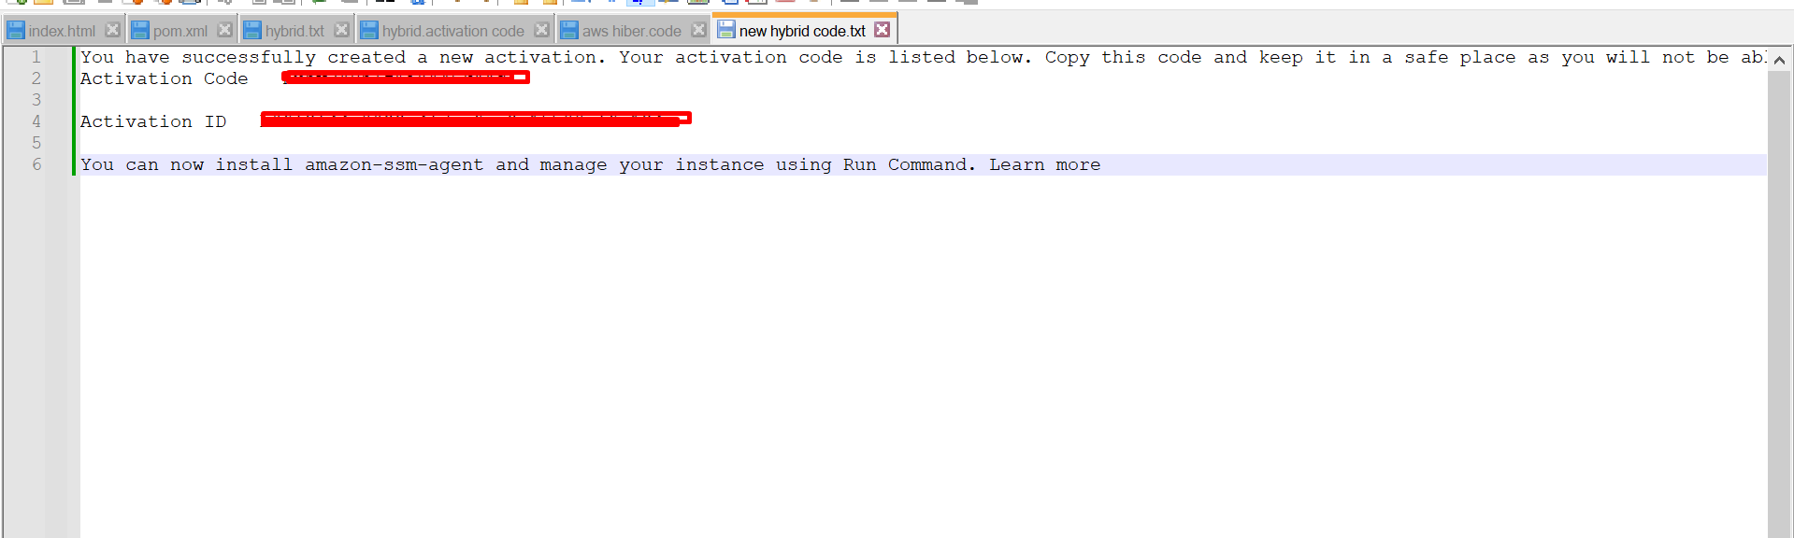

After that we send this code to who are monitor our system.

We must remember one thing this are very confidential do not send anyone expect who are monitor your system.

**Note**: - here we send our code to another employee and also I receive him code.

After receiving our employee activation code and add that activation code, id and region to script.

**Note**: - here script is not displays if we want that script search google.

Next we open power shell administrator

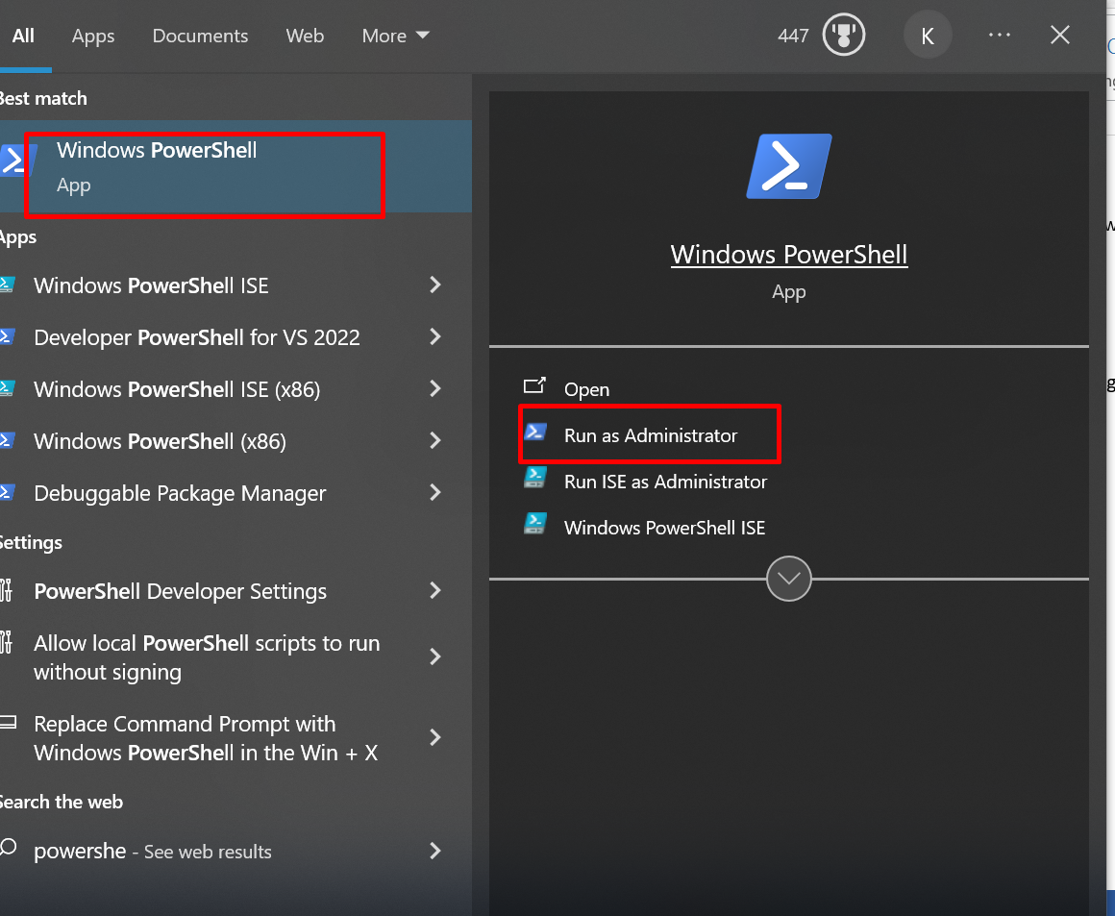

Next we copy that script and paste in power shell and click enter.

When we receive this **mi-####################** id.

We did correct process.

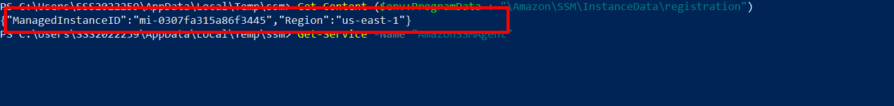

**Note**: - here we had some issue on SSM agent installation and we successfully solved (**recreated**).

So the **managedinstanceID** was changed**.**

After that we go **system manager** in aws – go to **fleet manager** here we see our managed instance id and check ping status in **online** and **select that instance** – next go to **node action** – next **select** connect – next **select connect with remote desktop**.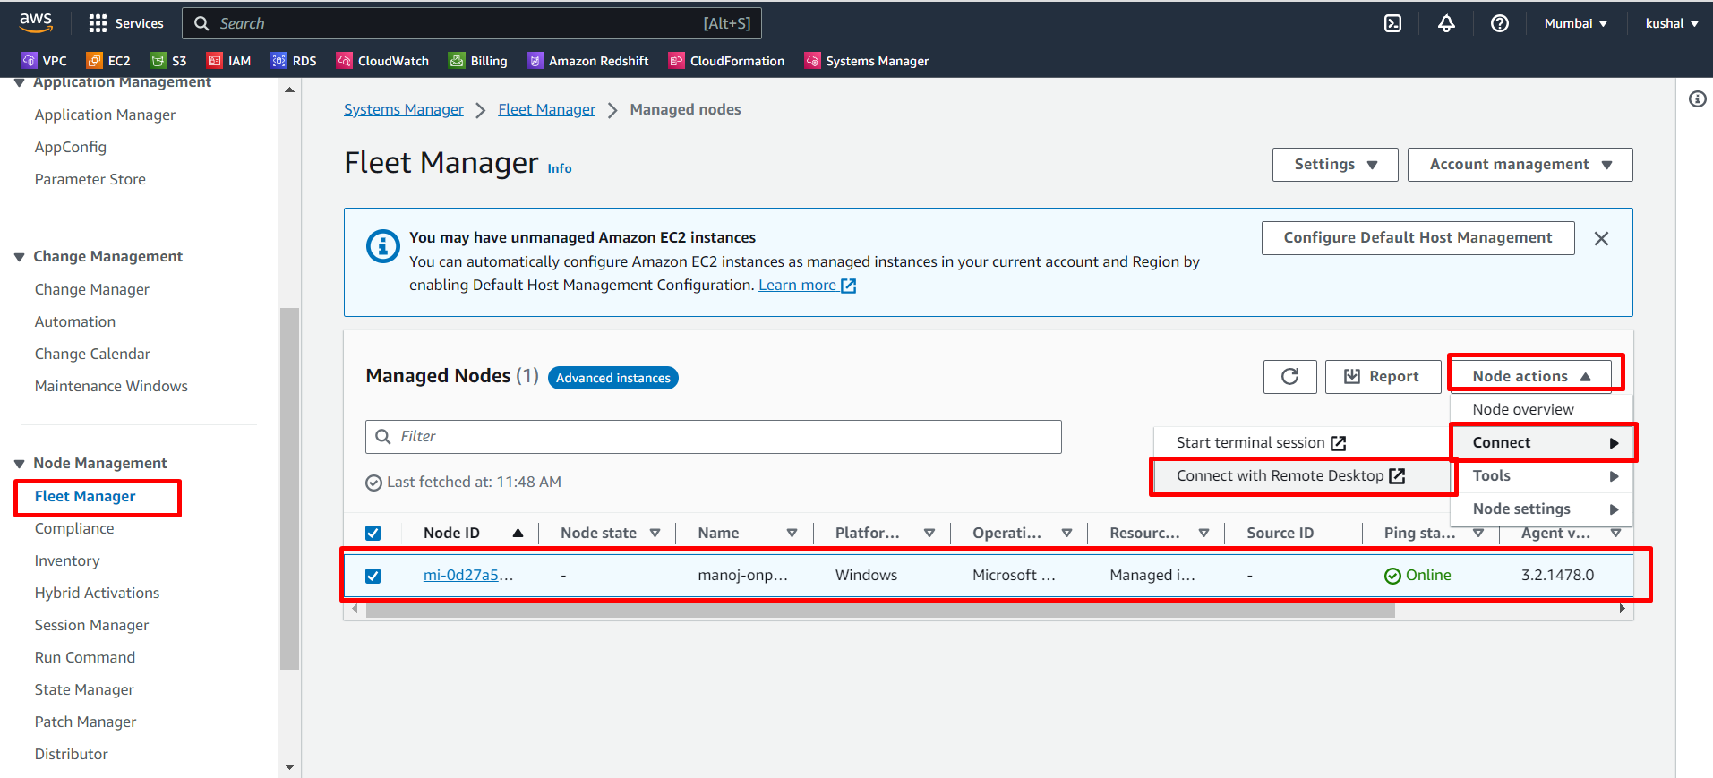

After that we enter another system username and password.

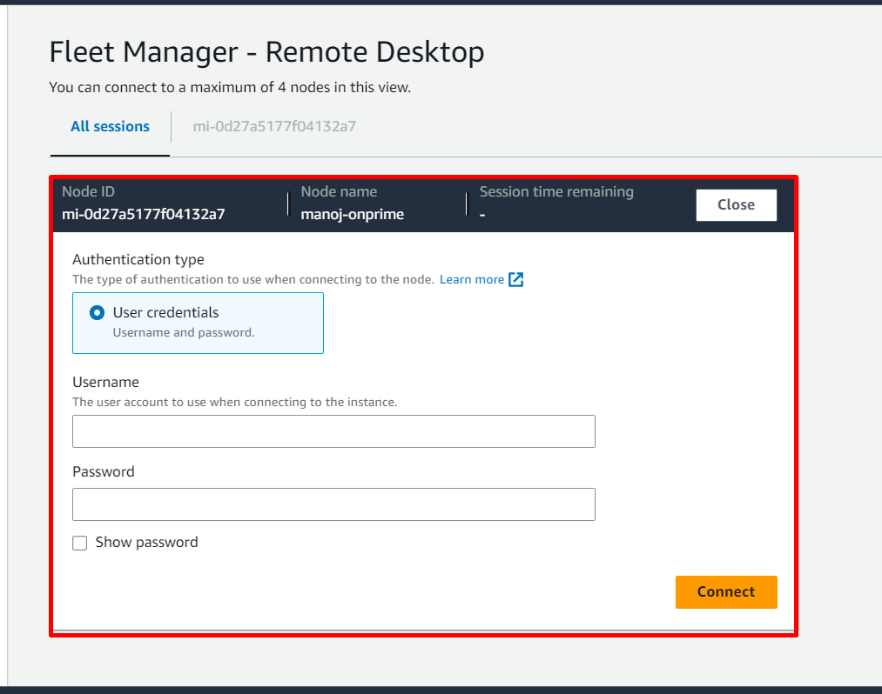

After enter username and password next select **connect**.

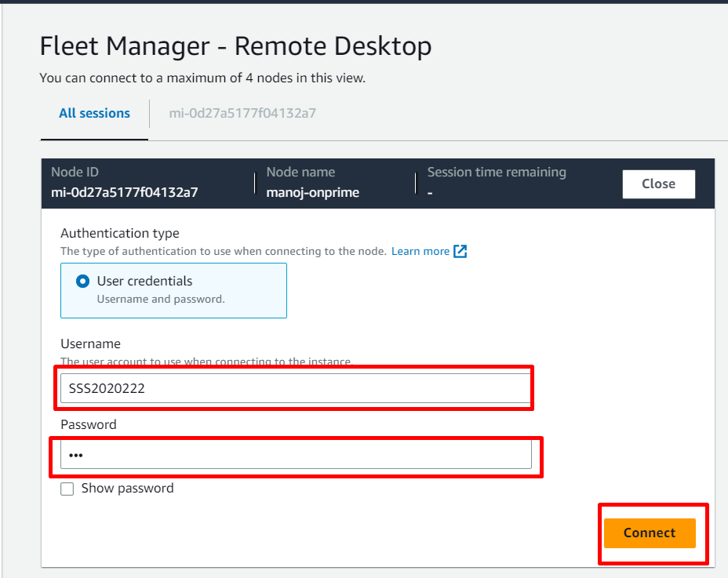

We successfully connected another system in our system by using hybrid activation, now we do work on that.

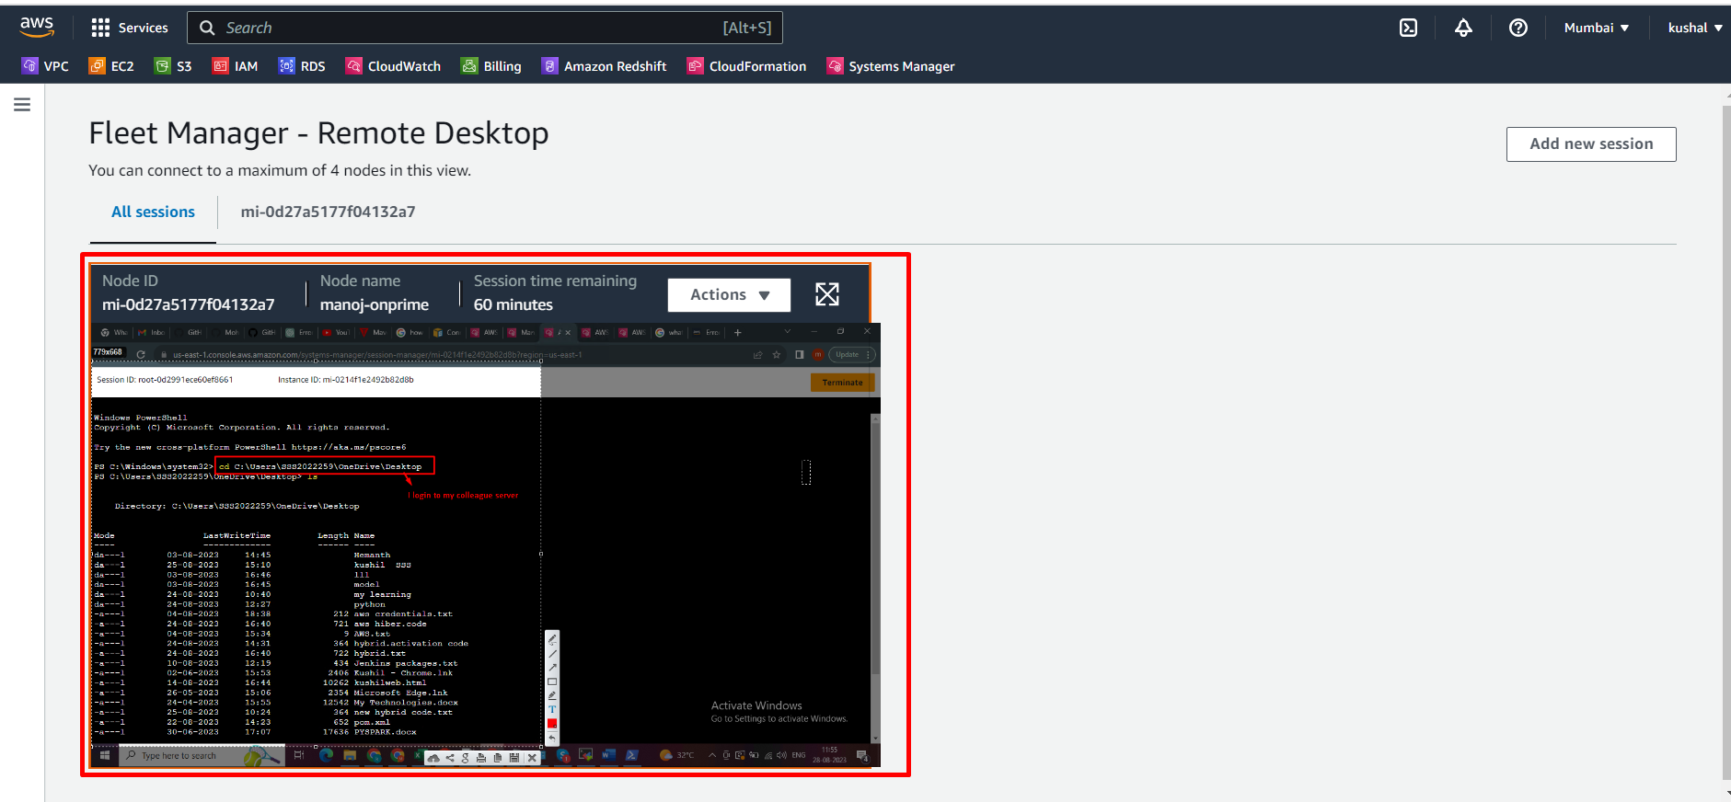

**THANK YOU**